CAPSTONE PROJECT
E-Commerce Mobile Classification
Using Machine Learning

Sanjaikumar S
DA & DS
February 2025

Objective:
To analyze product data from an e-commerce platform (e.g., Flipkart) to understand mobile product patterns, group similar products using clustering, and classify them into appropriate categories using machine learning algorithms.
1. Data Collection:
- Source: Data scraped from Flipkart using Selenium and BeautifulSoup.
- Features Extracted:
  - Product Name
  - Price
  - Rating
  - Number of Reviews
  - Category
2. Data Cleaning:
- Removed missing or null values.
- Converted prices and reviews to numeric format.
- Standardized categories and ratings.
- Stored cleaned data in MySQL database using SQLAlchemy.
3. Exploratory Data Analysis (EDA):
- Distribution of ratings, prices, reviews visualized using seaborn and matplotlib.
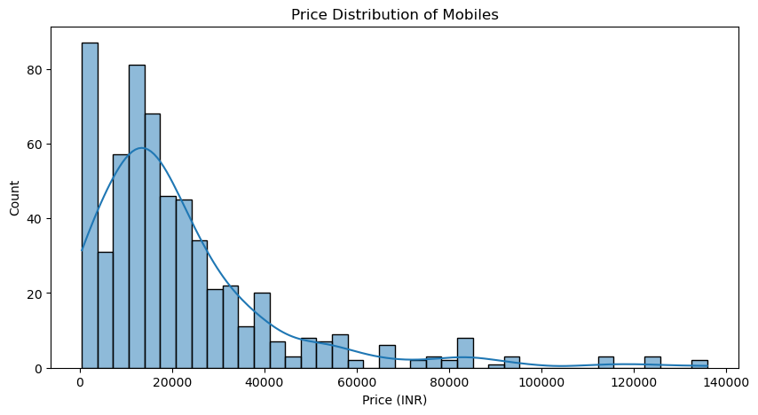
- Box plots and histograms helped identify outliers and understand spread.
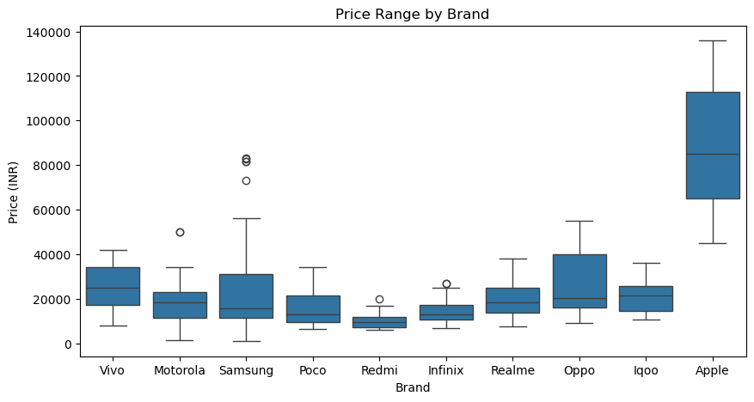
- Correlation matrix used to identify relationships among numerical features.
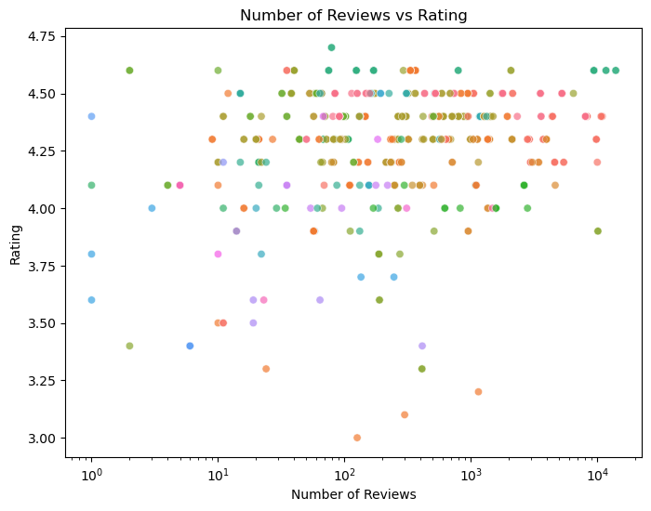
4. Dimensionality Reduction (PCA):
- Applied Principal Component Analysis (PCA) to reduce feature dimensionality.
- Normalized data using StandardScaler.
- Chose optimal number of components to explain maximum variance (e.g., 95%).
- Transformed original data into PCA space for better clustering performance.
5. Unsupervised Learning (Clustering):
- Used KMeans clustering on PCA-transformed data.
- Chose optimal number of clusters using Elbow Method.
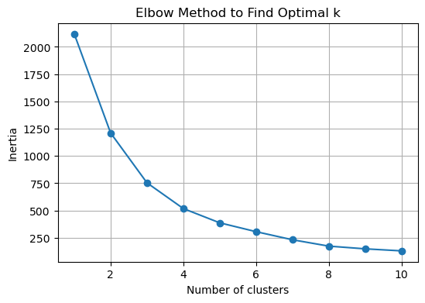
- Assigned cluster labels to each product.
- Created new target variable (labels) for supervised learning.
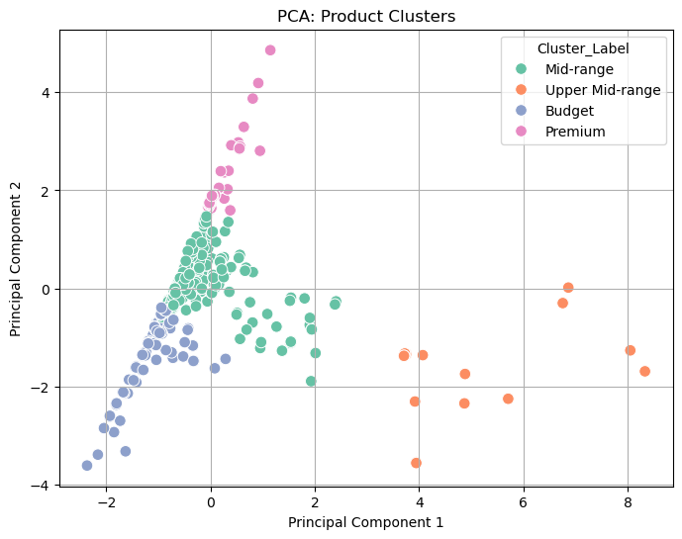
6. Supervised Learning:
- Used the cluster labels as target variable to train classification models.
Models Trained:
- Logistic Regression
- Support Vector Machine (SVM)
- k-Nearest Neighbors (k-NN)
- Random Forest
- XGBoost
Preprocessing:
- Applied SMOTE for handling class imbalance.
- Performed Train-Test Split.
- Normalized or scaled features where needed.
7. Model Evaluation:
- Evaluated models using:
  - Accuracy
  - F1 Score (macro)
  - Confusion Matrix
  - Classification Report
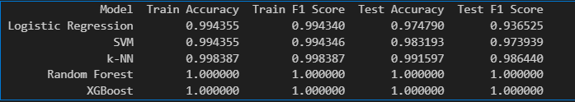
- Best Models:
  - Random Forest (best on test F1)
  - XGBoost (best after hyperparameter tuning using RandomizedSearchCV)
8. Hyperparameter Tuning:
- Used RandomizedSearchCV for XGBoost.
- Used GridSearchCV for Random Forest.
- Tuned parameters like n_estimators, max_depth, learning_rate, etc.
9. Model Saving:
- Saved final models using joblib:
  - best_rf_model.joblib
  - best_xgb_model.joblib

